
Short Exam N°2– Computer Vision 2023

1 h – No document allowed except lecture slides and notes (18 points)

Part 1: Camera calibration.

The camera shown in Figure 1 has its x, y and z axes aligned with the world's y, z and x axes respectively. The world frame's origin is at (0; -h; 4h) in the camera's frame.
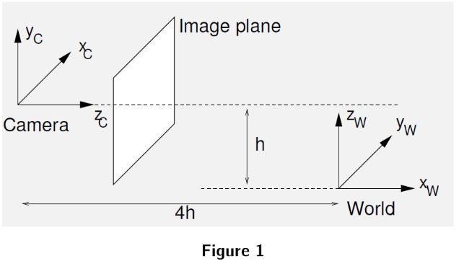

Question 1 (2 points – 5 mn): By deriving a succession of Euclidean transformations, find the camera's extrinsic camera calibration matrix [R|t], such that:
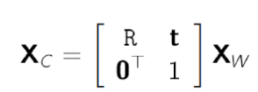
Ans: rotation Rx of 90° around X then a rotation Rz of -90° around Z (so R = Rx * Rz), next a translation.
1 0 0 0 1 0 0 1 0
Rx= 0 0 1 Rz= -1 0 0 R= 0 0 1
0 -1 0 0 0 1 1 0 0

Then 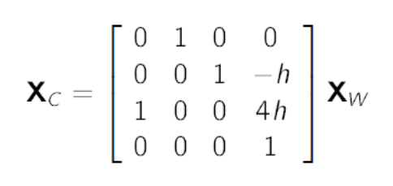

Question 2 (2 points – 5 mn): The “ideal" image plane is placed at z_{C} = 1. (Ideal means that the intrinsic camera matrix K is just a 3x3 identity matrix.) Derive the image coordinates of the vanishing point of the family of lines parallel to the following line, expressed parametrically as:

(X_{W}; Y_{W}; Z_{W}) = (2 + 4t; 3 + 2t; 4 + 3t)

Ans: K [R|t] = [R|t]

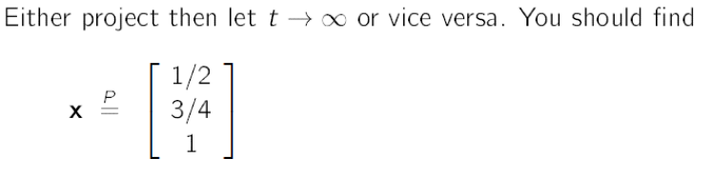

Xw/Zw = (2+4t)/(4+3t) = ½ when
Yw/Zw = (3+2t)/(4+3t) = ¾ when

Question 3 (2 points – 5 mn): The intrinsic calibration matrix maps ideal image positions onto actual positions in pixels. Explain, with the aid of diagrams, the physical meaning of the focal length f, the aspect ratio γ, and the principal point (u_{o}; v_{o}), and show why and where they appear in the calibration matrix. (Assume the skew s is negligible.)

Ans : see lecture notes (slides 5 and 21 of lecture 3b)

Question 4 (2 points – 5 mn): The actual camera has f = 800 pixels, γ = 0:9, s = 0, and (u_{o}; v_{o}) = (350; 250) pixels. Derive the coordinates in the actual image plane of the vanishing point of question 2.

Ans : 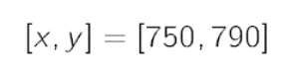

Part 2: Camera calibration.

Question 5 (2 points – 5 mn): Starting with the projection equation x = PX = K [R|t] X (all up to scale), describe an algorithm which uses the measured image positions (x_{i}; y_{i}) of at least six points with known positions in the world (X_{i}; Y_{i}; Z_{i}) to recover the extrinsic and intrinsic calibration parameters.

Ans : see lecture notes (slide 18 of lecture 4); P has 12 unknowns, so to recover the extrinsic and intrinsic parameters we need 12 equations, and as we have 2 equations per pair of corresponding points we need 6 points with known positions.

Question 6 (4 points – 15 mn): Let us suppose that K is defined as below, and that we know the image positions (x_{i}; y_{i}) of six points of a unit cube defined by the following positions in the world (X_{i}; Y_{i}; Z_{i}) explain the process to get the coefficients of the matrix P (up to scale).
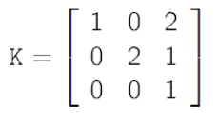
(x₁; y₁) = (2 ; 1/2), (X₁; Y₁; Z₁) = (0; 0; 0)
(x₂; y₂) = (9/4 ; 1/2), (X₂; Y₂; Z₂) = (0; 1; 0)
(x₃; y₃) = (9/4 ; 1 ), (X₃; Y₃; Z₃) = (0; 1 ; 1)
(x₄; y₄) = (2 ; 1 ), (X₄; Y₄; Z₄) = (0; 0 ; 1)
(x₅; y₅) = (2 ; 1 ), (X₅; Y₅; Z₅) = (1; 0 ; 1)
(x₆; y₆) = (11/5; 1 ), (X₆; Y₆; Z₆) = (1; 1 ; 1)

Hint : From the 6 points we get 12 equations, from these equations we get the R and T unknowns. Remind that:
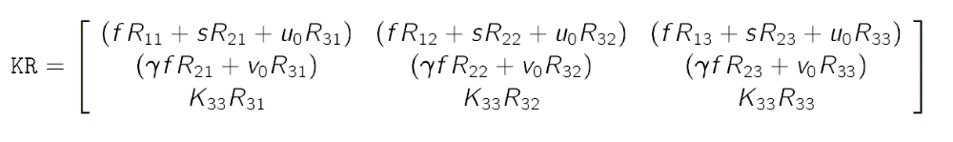
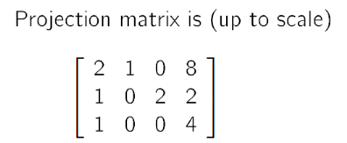

Part 3: Short questions.
Question 7 (1 point – 5 mn): The intrinsic parameters of two cameras are given by the following matrixes, which of these two cameras would you prefer to use? Explain your choice.
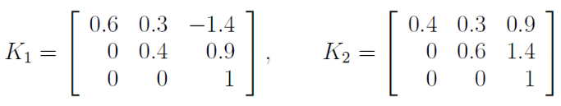
Ans: see slide 21 of lecture 3b. We prefer to have positive translation shifts in the image plane (ie k2) than any negative shift (as with k1).

Question 8 (2 points – 10 mn): A pinhole camera projects a 3D point P, located at coordinate [1; 0; 0]^{T} in the world coordinate system, onto the image at point p using the projection matrix M, as p = MP, where:
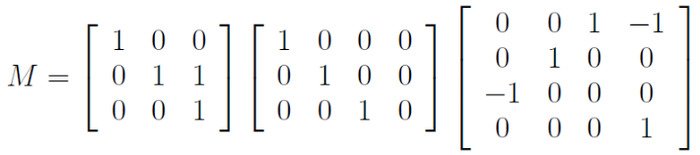
Compute the image coordinates of p. Compute the following camera parameters: Focus; Skew; Offset along x axis; Offset along y axis; Scaling.

Ans: see slide 21 of lecture 3b. The first matrix corresponds to K, so:
f sx = 1
f sy = 1
Sθ = 0
ox = 0
oy = 1
f sx = f sy, so sx = sy

p = (-1, -1, -1)^{T}
As the third coeff should be = 1 (with homogeneous coord) we must factorize the value -1, so p = (1, 1)^{T}

Question 9 (1 point – 5 mn): From the specification of M, and the standard definition of the 3D rotation matrix
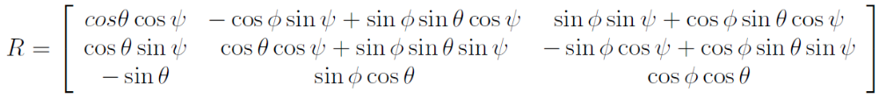,
the transform that maps the world coordinate system of P to the camera coordinate system is characterized by the following rotation angles = 90°, = 0°, and = 0°. Compute the Euclidean distance between P and the camera center at the moment of capturing the image.

Ans:
0 0 1
R = 0 0 0
-1 0 0

The rotation of the coordinate system does not impact the computation of the Euclidean distance, if there is no translation then the distance is equal to zero.

